**Part 1 Tutorial**

**1. Why are genetic algorithms considered to be bio-inspired?**

Genetic algorithms are based on natural selection. Natural selection is the process that drives biological evolution.

**2. What are genetic algorithms (GA) user for? Give an example of what you might use a GA for?**

Optimization: Solving intractable NP-Hard problems including travelling salesman problem and timetable scheduling. Computational Biology: Simulate biological processes to provide inspirations for biologist.

**3. Describe the main steps in a GA. Show the steps in a flowchart.**

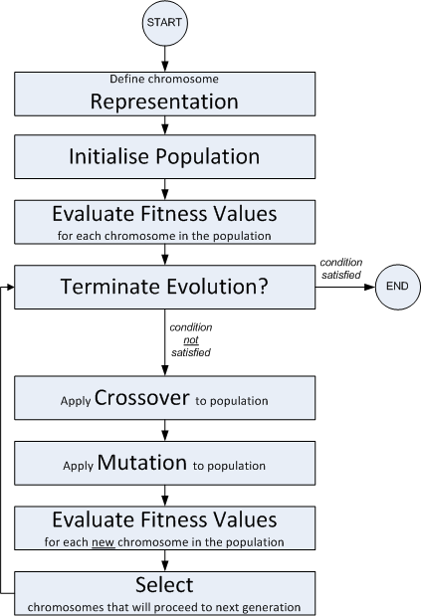

**4. What are the purposes of the following in a GA?**

* Evaluation or fitness function Measure the quality of each candidate solution.
* Mutation operation Exploring new solutions.
* Selection operation Pick up better solutions among all the candidate solutions.
* Crossover operation (Hopefully) combine good traits of quality solutions.

#### 5. Suppose you have to find the maximum turning point of a function y = f(x). You are given that the x-value of the point lies in the interval [x1, x2] and the y-value of the point lies in the interval [y1, y2]. Design a GA that can solve it. In your design, include the type of chromosome and selection method etc. that would be appropriate and suggest values for settings where required.